Rajasthan E-Waste Signature
State-level diagnostic document based on the Rajasthan project dataset
Assignment component 3. This document summarizes the e-waste profile and environmental-signature indicators used in the Rajasthan project.

1. Rajasthan e-waste profile
The project Excel workbook divides generated e-waste into IT & Telecom, Consumer Electrical & Electronics, Large & Small Equipment, Lighting, Batteries and Other categories. The working dataset contains district-level entries and a state total.
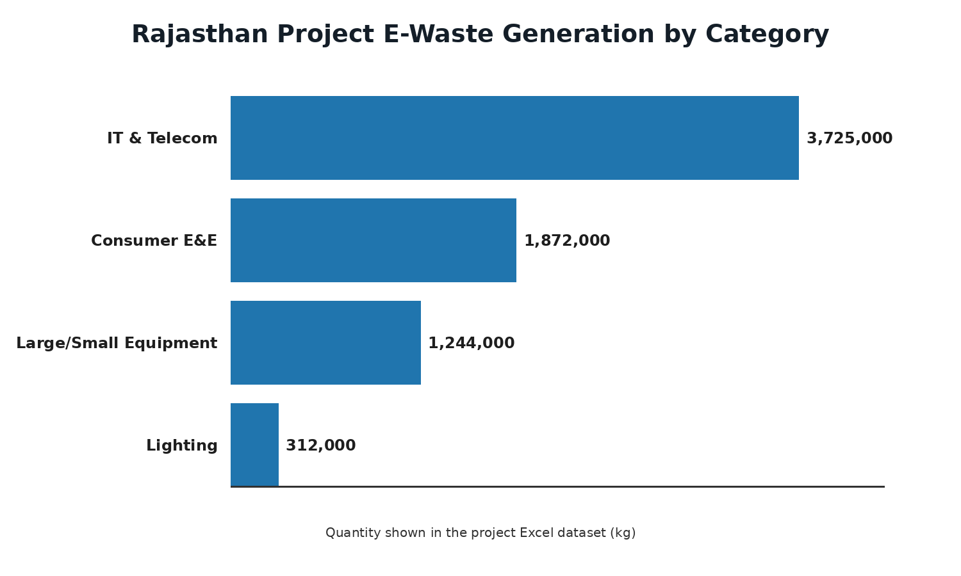

2. State total shown in the project Excel dataset
Category | State total (kg)
IT & Telecom | 3,725,000
Consumer Electrical & Electronics | 1,872,000
Large & Small Equipment | 1,244,000
Lighting | 312,000
Batteries | 0*
Other | 0*
Total shown | 7,153,000
*The zero values above reflect the working project sheet shown in the supplied screenshots; they should not be interpreted as an official Rajasthan-wide absence of battery/other e-waste.

3. District-level coverage in the working dataset
The project workbook includes district entries such as Jaipur, Jodhpur, Alwar, Udaipur, Kota, Ajmer, Bikaner, Bhilwara, Bharatpur, Sikar, Pali, Nagaur, Churu, Barmer, Jhalawar, Bundi, Hanumangarh, Dausa, Rajsamand and Tonk. District values were used to build the tracker and state total.

4. Collection and recycling indicators
- The tracker records generated quantities, collected quantities, registered collection centres and EPR collection targets/achievements.
- The recycling-infrastructure sheet records recycler/dismantler name, CPCB/SPCB authorization, district, installed capacity and quantity processed.
- The compliance sheet records EPR entities, registration, inspections and enforcement-related fields.
- The informal-sector sheet records hotspots, estimated workers, workers registered/trained and formalization actions.
- The environmental-health sheet records monitoring sites, monitoring type, date, result, health camps and beneficiaries.

5. E-waste signature – how to interpret it
An e-waste signature is a pattern of elevated contaminants or metal concentrations associated with e-waste handling compared with a background or control location. For Rajasthan, the project should use measured hotspot-versus-background values only where they are supported by the referenced study or sampling dataset. The Excel tracker itself mainly describes quantities, collection, recycling infrastructure, compliance, informal-sector and monitoring indicators.

6. Diagnostic interpretation for Rajasthan
- The working dataset shows a large contribution from IT & Telecom and Consumer Electrical & Electronics categories.
- The presence of formal recyclers/dismantlers and collection centres can be used as an indicator of formal recovery infrastructure.
- Collection achievement should be compared with the EPR target to identify the gap requiring improvement.
- Informal-sector hotspots are important because unsafe dismantling can release metals and persistent contaminants into soil, dust and water.
- Environmental monitoring and health camps provide supporting evidence for evaluating the environmental and health dimension of e-waste management.

7. Rajasthan-focused visual: diagnostic signature
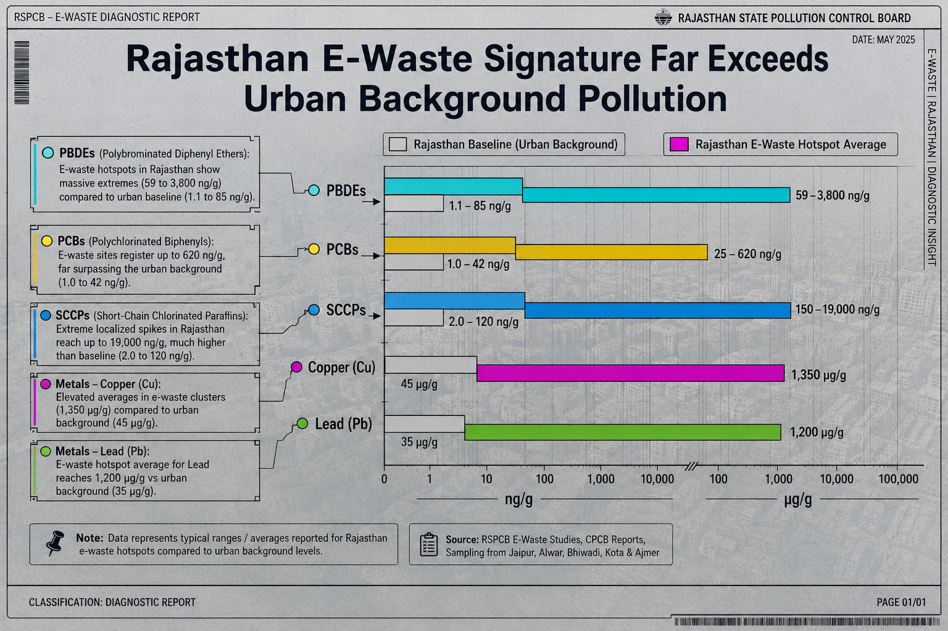
Figure: Rajasthan e-waste diagnostic-style visualization prepared for the project. Numerical pollutant values in this visualization should be treated as illustrative unless independently verified against the cited Rajasthan sampling study.

8. Conclusion
Rajasthan's e-waste management assessment should combine generation data with collection performance, formal recycling capacity, EPR compliance, informal-sector integration and environmental-health monitoring. The project Excel tracker provides the framework for these indicators; measured contaminant values should be added only from verified field or published sources.

9. Data note
Important: The numerical generation and tracker entries in this document are based on the working project dataset developed for the assignment from the Excel sheet/screenshot values. They are not presented here as independently verified official Rajasthan statistics. Official claims should be checked against CPCB/RSPCB publications before external publication.

